Top 10 Speakers

Bottom 25 Speakers

Likes & Views per Year

Likes & Views per Month

Views Per Speaker

Likes Per Speaker

More than million likes

Up to 200K likes

Ted shows per month

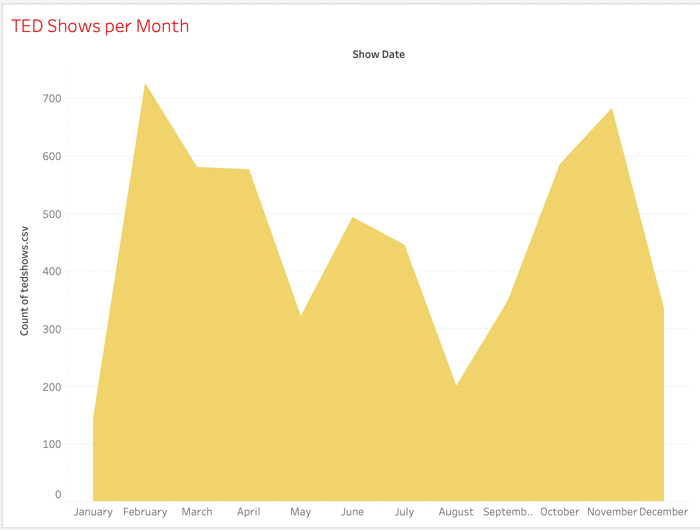

Number one Speaker

Average views and Likes per Year

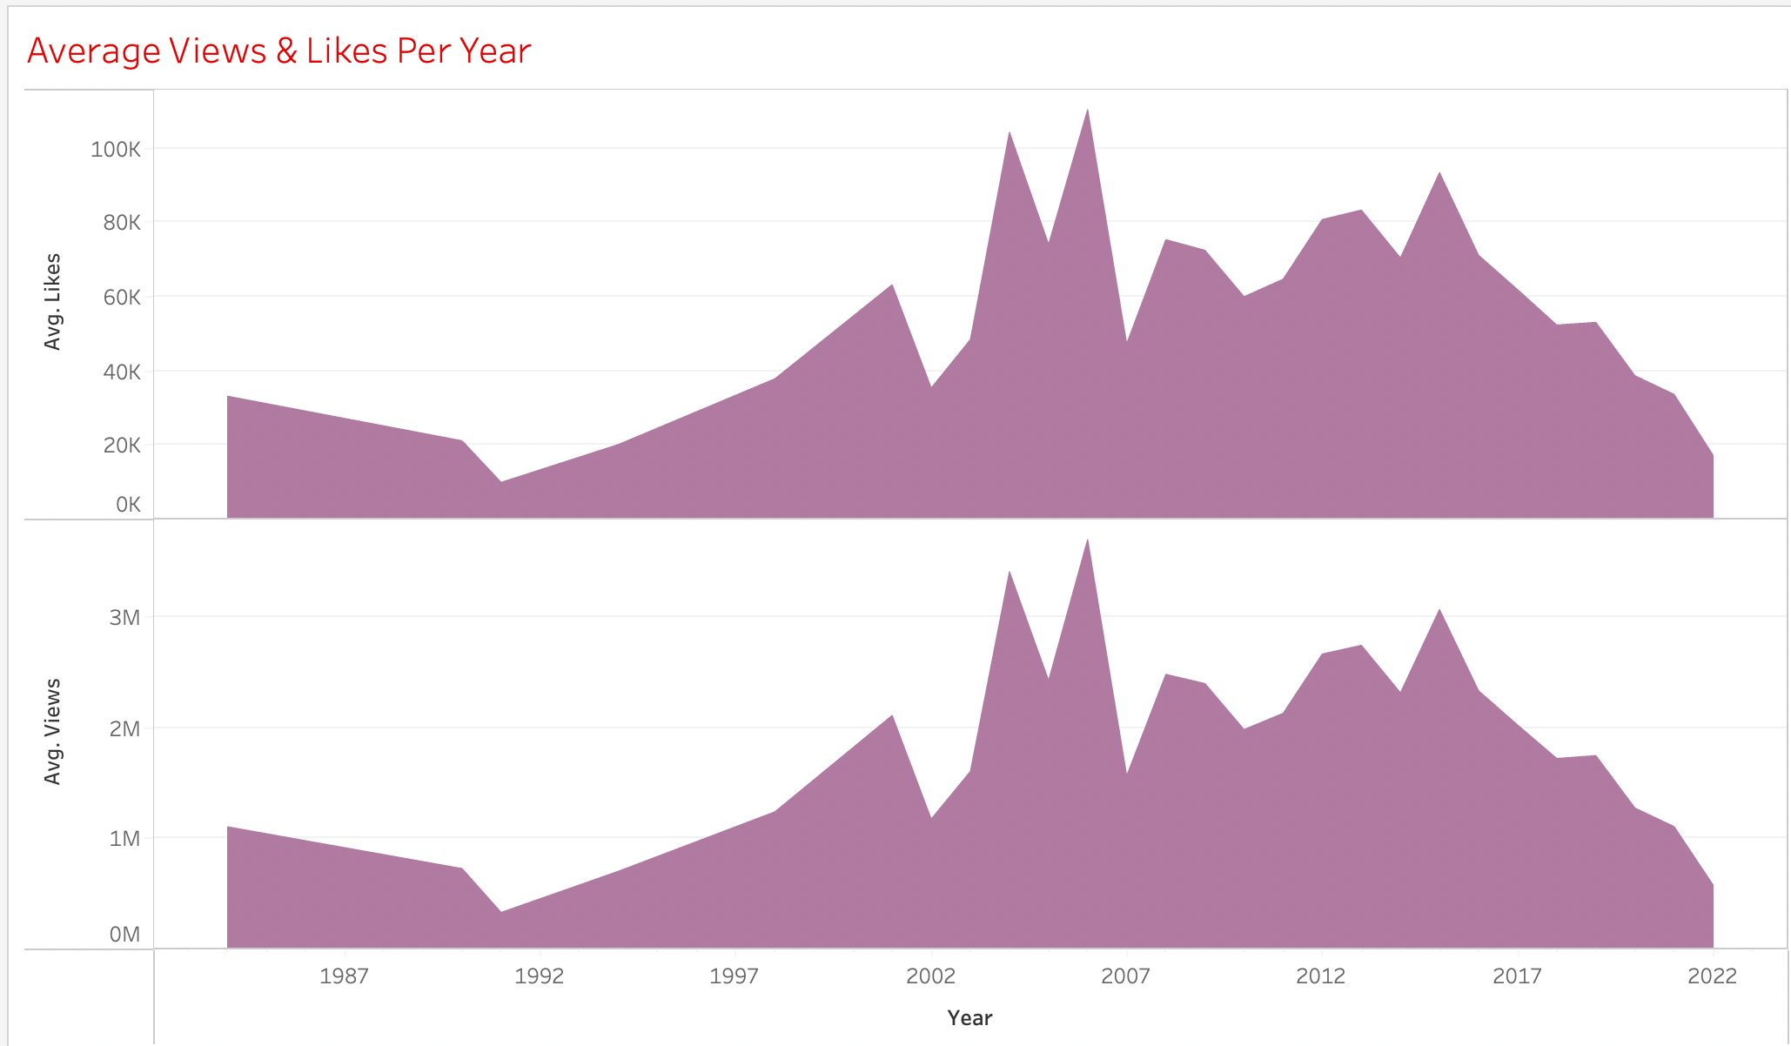

Dashboard

